CW2: High-Fidelity Design Portfolio, Heuristic Evaluation and Assessment Criteria

The following design portfolio showcases a functional prototype of a Web-based Desktop Task Manager System. The system developed in this portfolio will allow users to manage their tasks by keeping track of the tasks which are completed or not, while providing additional functionality like notifications. The Task Manager is being designed to help users having difficulty in keeping track of their tasks using paper media but also for users who want something new from their task manager. The system provides 2 different viewpoints of their tasks for them to select based on their preference. This prototype was created on Visual Studio Code using HTML to structure the web pages, CSS to style the pages and JavaScript to add functionality. It also uses the framework Bootstrap.

# **Key User Requirements:**

* View tasks in different views.
* Ability to add tasks.
* Able to edit tasks.
* View tasks that are to be completed.
* View tasks that are done.
* Ability to mark tasks as done.
* Able to delete tasks.
* View notifications for tasks with close deadlines.
* Different task categories.
* View profile details.
* Edit account details.
* Settings to change font.
* Change themes.
* Navigation bar.
* Guide to using the task manager.

# **Development list of features**

**Feature 1:** Homepage

New users will need to first view information about what kind of system it is, hence, a homepage is needed as it is the most likely place a new user will view, which will contain the information they are looking for.

**Feature 2:** Task List

A page dedicated to the tasks is necessary, as this is the main reason the user is using the system, hence a page where the user can view and manage their tasks is needed.

**Feature 3:** Settings

If a user wants to change something with the system, the user will navigate to the settings page which is why it is important to have a section dedicated to customising the settings of the system to match the user’s preference.

**Feature 4:** Notifications

Notifications will be used for the user to see which upcoming task deadline is getting close, by displaying a notification for the relevant task. It will showcase which task is more of a priority than the other tasks.

**Feature 5:** Profile

A user viewing their profile is needed so they can view their details, to see if they need to be updated.

**Feature 6:** Navigation Bar

The system needs some form of navigation between the different pages, hence a navigation bar with the links to the different pages is needed.

**Feature 7:** 2 different views.

This feature will allow the user to change how they are viewing the task based on their preference, with a board and list view. This feature will allow the user to be more comfortable with the system.

**Feature 8:** Notifications

Notifications will be used for the user to see which upcoming task deadline is getting close, by displaying a notification for the relevant task. It will showcase which task is more of a priority than the other tasks.

**Feature 9:** Upcoming Task Section

Having a section on the task list page dedicated to upcoming tasks will help the user to see which tasks still needs to be done.

**Feature 10:** Completed Tasks Section

A section where the user can see tasks, they have previously completed will help the user to see which task they have done in case multiple tasks related to one big task. This feature will help the user to stay organized and be clear on what needs to be done.

**Feature 11:** Categories for tasks

Having different categories for tasks will help the user to differentiate what they task is for, helping the user to stay organise.

**Feature 12:** Create a task

Creating a task is the most important feature, as without it the user will not be able to add any task to the system.

**Feature 13:** Mark a task as done.

Having the ability to move a task to done is important as the user needs to be able to clearly tell which task are done and which are not.

**Feature 14:** Edit a task

It is important to be able to edit a task in case the user made a mistake whilst creating the task hence they would want to be able to edit it.

**Feature 15:** Deleting a task

A user needs to be able to delete a task so they can clean up tasks that have become redundant to make it easier for the user to navigate.

**Feature 16:** Change themes.

Switching themes between light and dark is important as an option for the user to select their preferred choice of customisation of the system.

**Feature 17:** Two Factor Authorisation

An option to enable and disable two factor authorisations is important so the users’ data is protected more, hence providing a more secure system for the user to trust and use.

**Feature 18:** Edit account details.

A form for the user to edit their details needs to be provided to the user if details need to be updated or added.

**Feature 19:** Font Family settings

A way to change the font family of the site will help to make the site more accessible to users with poor eyesight as they can select a font family.

**Feature 20:** Login.

A login form is needed so a registered user can access their account to view or manage their tasks and interact with the system.

# **Annotated Screenshots**

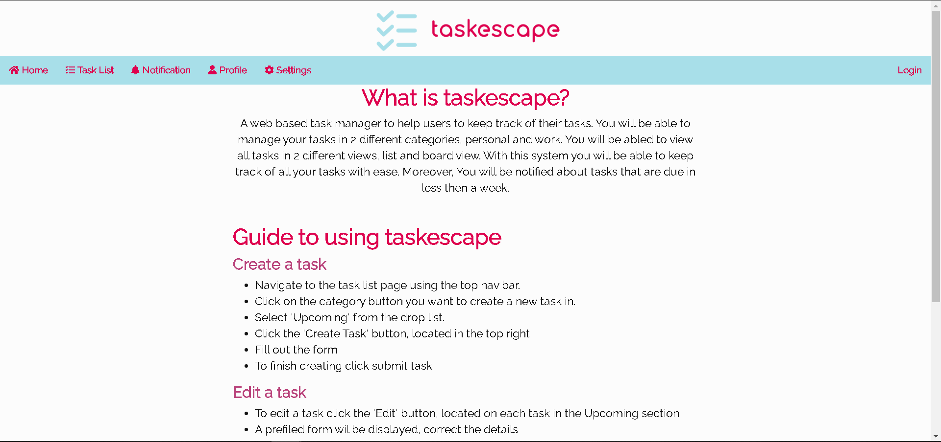**Homepage**

Bullet point list to explaining how to use the feature.

Subheadings for each feature in the guide

Paragraph text

Main heading of the section

**Description**

This the homepage shown when the menu item Home is clicked. The page contains information about what this system is and the things you can do with it. Then there is a guide to using the system. The guide is organized in with subheadings for different features, with each containing a bullet point list explaining how to use the feature.

**Functionality/features:**

* A simple layout using bullet points with headings.

**Requirements met:**

* Guide to using the task manager.

**Accessibility:**

* Simple theme used so the user can read all the text without interference from colours.
* Bullet point list used to easily follow each step of the guide.
* Text has been centered to make it easier to follow through.
* Clear headings for each part of the text so the user knows what the text is for.

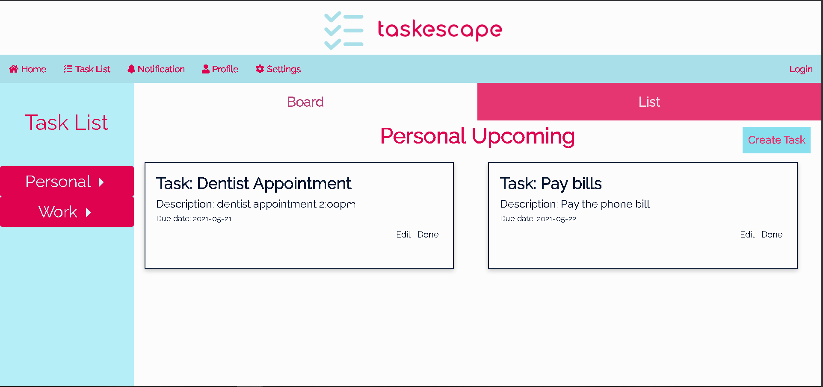**Task List Page – Upcoming Personal tasks, board view**

Displaying each task with the title, description, and due date.

Button to mark task as done.

Button to edit the task.

Button to create a task.

Board view selected.

Buttons to navigate between personal and work tasks.

**Description**

Task List page currently selected

Personal upcoming tasks currently being displayed.

When the user navigates to the task list page using the navigation bar, this is the page that will be displayed to the user. This page will display the user their upcoming for personal tasks by default. The user will be able to view their tasks in 2 different views using the Board and List view buttons. On this page you can create tasks, edit tasks, and mark tasks as complete.

**Functionality/features:**

* Able to view all task within the selected section.
* Tasks are saved and loaded using local storage and accessed using an array.
  + In the final product the task would be saved and load from a database, for versatile access from anywhere.
* The category task buttons are drop down boxes, options to navigate between upcoming and done.
* Clear heading for which section is currently being shown.
* Buttons to select preferred view.
* Selected view changes colour.
* Clear text buttons to manage the tasks.

**Requirements met:**

* Different task categories.
* Different views for the task.
* Navigation bar.

**Accessibility:**

* For the main body which shows the task no colours were used to prevent the user from being overloaded with colours.
* Blue and pinkish red was used for the default light theme for easier contrast, primary colours work well together.
* Different font sizes were used for differentiation of text based on importance.

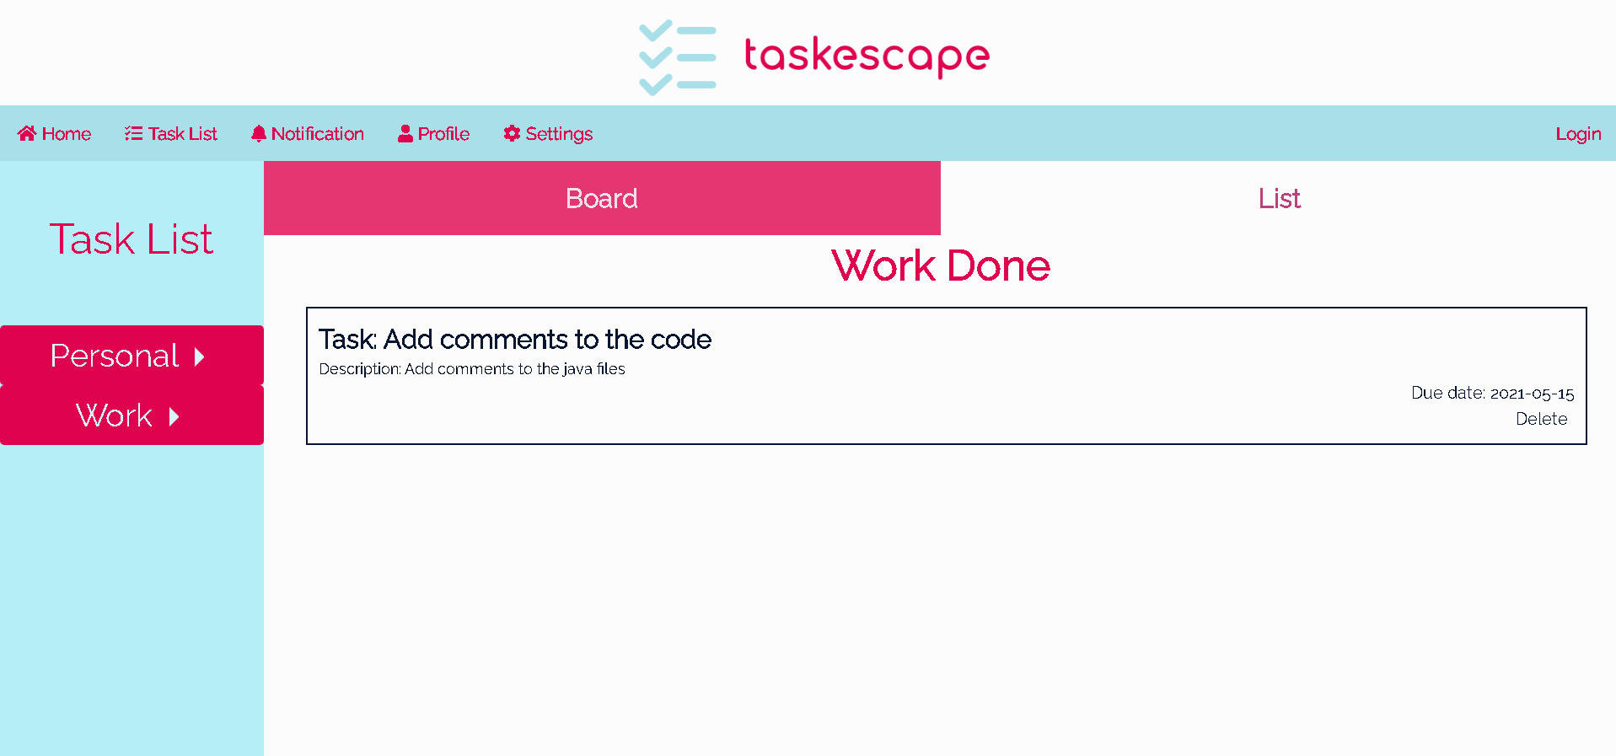**Task List Page – Done Work tasks, list view.**

Button to delete the task.

Tasks are being displayed in a list, one after another, with all task details.

List view currently selected.

Displaying tasks that have been completed for the Work category.

**Description**

This page is when the user navigates to the done work tasks using the Work drop down button and selecting done. List view has been selected hence the tasks are being shown in a list. Each task in the list has all the task details with a button named Delete, used to delete the task.

**Functionality/features:**

* A separate section to view tasks that are completed.
* Same as upcoming tasks, the whole array of done tasks is being saved in the local storage.
* Text button named Delete to delete the task.
  + The task is being deleted from the array and then resaving the array to the local storage, in the final product a database would store all the tasks so only need to delete that task without needing to resave all the tasks.
  + The task is being deleted by searching the whole array for the task with the matching id, in the final product a simple database query can be used saving resources.

**Requirements met:**

* Different views for the tasks.
* Section to view completed tasks.
* Able to move tasks to done.

**Accessibility:**

* Easy to delete tasks with a button click, no hassle.

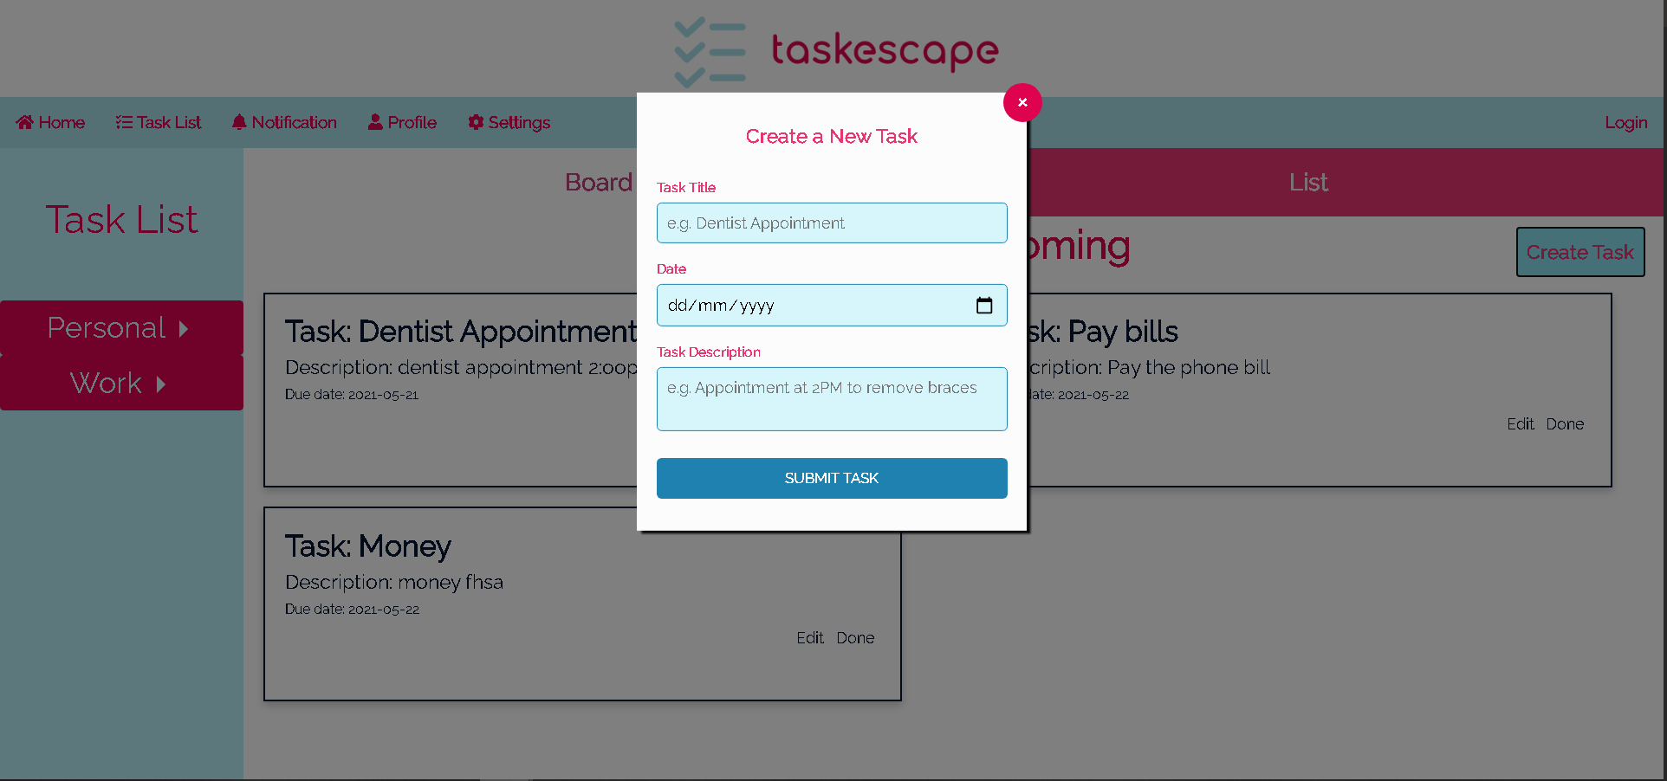**Task List Page - Create a task**

Popup window with the form.

A black transparent overlay.

Button to submit the details and create the tasks.

Input text field to enter the task details. 

A date picker to select the due date.

Button to close the popup.

**Description**

To create a new task, the button ‘Create Task’ is clicked. When clicked, a popup form will be displayed to the user for them to enter the tasks details. The user enters the details into the input fields, once filled, to finish creating the task, click the submit button task. The popup form can be closed using the X in the top right corner.

**Functionality/features:**

* Popup overlay to make the popup form stand out clearly.
* Date picker to select the date.
* Task description has a character limit.
* When saving the new task in local storage the whole array of tasks is being resaved.
* In the final product a database would be used to store the tasks, would be able to use an auto generated primary key to uniquely identify the task, currently using Date.Now() to generate a unique id.

**Requirements met:**

* Create new tasks.

**Accessibility:**

* Placeholder example text to give the user a hint and what format is being used in the input field.
* A date picker to make it easier to select the due date.
* Clear labels so the user knows what the input field is for.
* Character limits to prevent the user from overloading the tasks with information, helps to simplify the tasks.

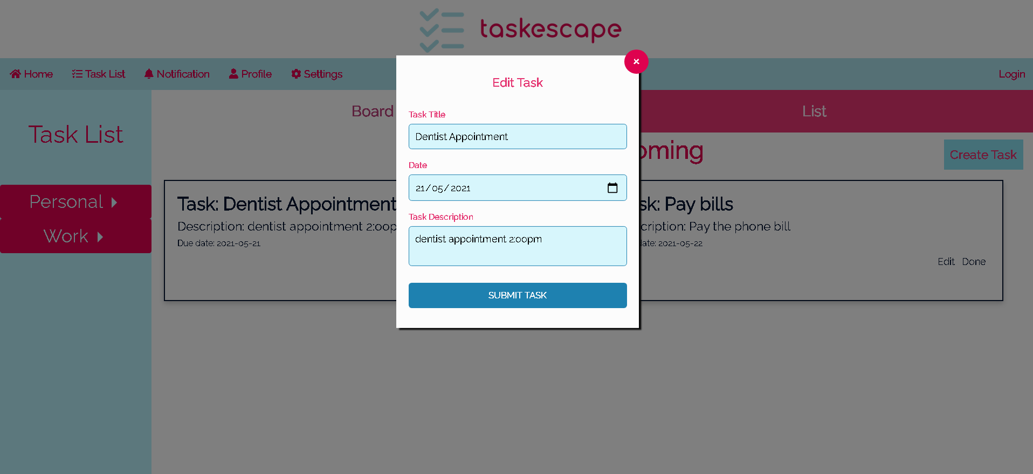**Task list page – Edit Task.**

Button to submit edited task details.

Input fields prefilled with the details.

Button to close the form.

Transparent overlay

Popup window with the form.

**Description**

This screenshot shows what happens when the user clicks the edit button the task. A popup form which is identical to the create task form is shown. The difference being the input fields are already pre-filled with the task to be edited details.

**Functionality/features:**

* Same features and functions like the edit task form
* Currently the task is being found by doing a loop to find the matching ID and then being edited by saving each task detail again, and then resaving the task to local storage.
  + In the final product, a database would be used hence a simple update query can be used to update the task.
  + In a database work and personal tasks can be kept separately in tables currently all tasks are saved in the same array which means the code is wasting time looking through tasks that are not in the same category.

**Requirements met:**

* Edit tasks.

**Accessibility:**

* Identical form to the create task form hence the user does not need to learn anything new when editing the task.

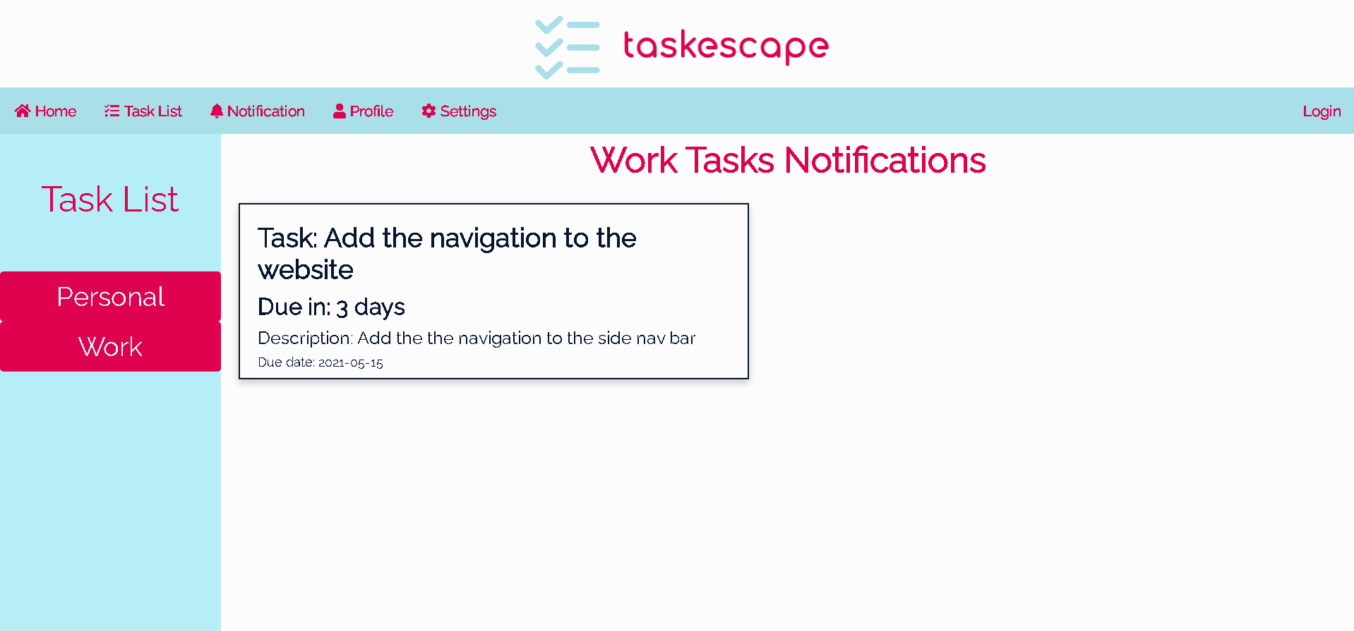**Notification Page**

Shows how many days left until the task is due in

Heading to show which category the notifications are for

**Description**

On the notification page, tasks that have a deadline upcoming within a week or less will be displayed. The user can see the notification for upcoming deadlines for each category. The notification will display all the task details, with additional data which shows how many days the task is due in.

**Functionality/features:**

* View the notification for each category.
* Depending on the due date different data will be shown to the user.
  + If 7 days or less left until the task is due, then it will show the number of days left.
  + If the task is overdue then, it will show how many days the task is overdue by.
  + If the current date and due date is the same, then today will be displayed.
* The task notifications are created when the DOM Content is loaded, it will filter out all the tasks that are upcoming in a week or less and create a notification.
  + In a final product a database search query would make it easier to find all the tasks and then be able to create and push notifications to the user in the background instead of creating them when the page is loaded.

**Requirements met:**

* View notifications.

**Accessibility:**

* Notifications colour scheme is plain for easy readability.
* It is clear as to how many days are left until the task is due.
* Easy to view the notification for each category for each task.
* Clear headings to show what is being displayed.

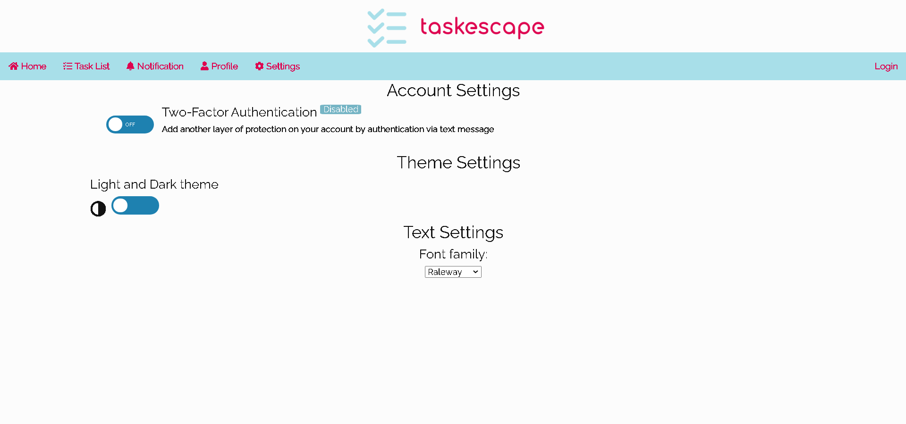**Settings Page**

Drop list to change the sites’ font family.

Toggle switch to switch between light and dark themes

Subheadings to tell the user what each section is for.

On and off toggle switch for the 2FA.

**Description**

In the settings page you can active two-factor authorization which would protect your account be sending a verification text. The 2FA can be activated using the ON and OFF toggle switch. Furthermore, customization to the site to make the user experience more comfortable. The user can use the toggle switch to change from light and dark theme. They can use the drop list to select a font that is more suitable for them.

**Functionality/features:**

* Toggle switch to activate 2FA.
  + Not implemented due to there not being a database and server for validation.
* Toggle switch to change between light and dark themes.
* Drop list to select the font family of the whole website.

**Requirements met:**

* Settings to change font.
* Change themes.

**Accessibility:**

* Simple back and white colour scheme, to prevent the user from being overloaded.
* Drop list used as users would be familiar with them.
* Toggle switches to easily change between themes.

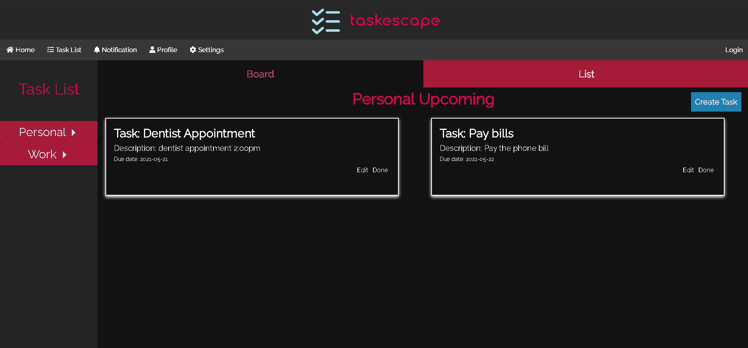**Task list page - Dark Mode**

A dark gray background and white text was used to make it standout.

A light grey then the main task body.

**Description**

When the toggle switch for dark theme is on, the whole site will go to a dark gray . The colour scheme will change to a dark background with bright colours for the text.

**Functionality/features:**

* Easy to switch between the themes.
* The theme currently selected is stored in the local storage, and it is checked every time the page is loaded with an if statement.
  + In a database the theme can be simple load without the need of an if statement.

**Requirements met:**

* Change themes.

**Accessibility:**

* High contrast colours used, white text with a dark gray used to make the text readable to users.
* Different shades of grey were used to elevate certain areas, to make it easier to differentiate the different areas of the site.
* Dark mode allows for less eye strain when viewing in dimly lit areas.

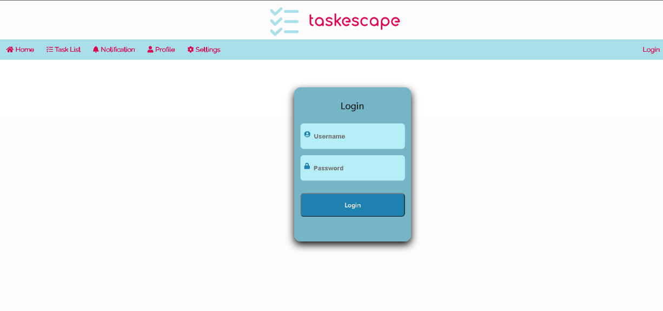**Login Page**

Login form

Input field to enter login details.

Button to login

**Description**

This is the login form for the user to login into. It is a simple form with input boxes for the username and password. Once the details are entered press sign into login into the system.

**Functionality/features:**

* Due to there not being a database the login form currently does not work as there is no way to store the users safely hence the form just shows what would happen.
* When details are entered the username and password are saved in the local storage so the profile page can show case how it would look.

**Requirements met:**

* Login

**Accessibility:**

* Blue colour scheme used to match the sites’ light theme.
* Icons are used to make it clear what each input is for.
* Placeholder text to help the user further which details they should enter.

**Profile Page**

Placeholder text

Button to save the account details.

Page subheading

Input field to enter the account details

User’s username

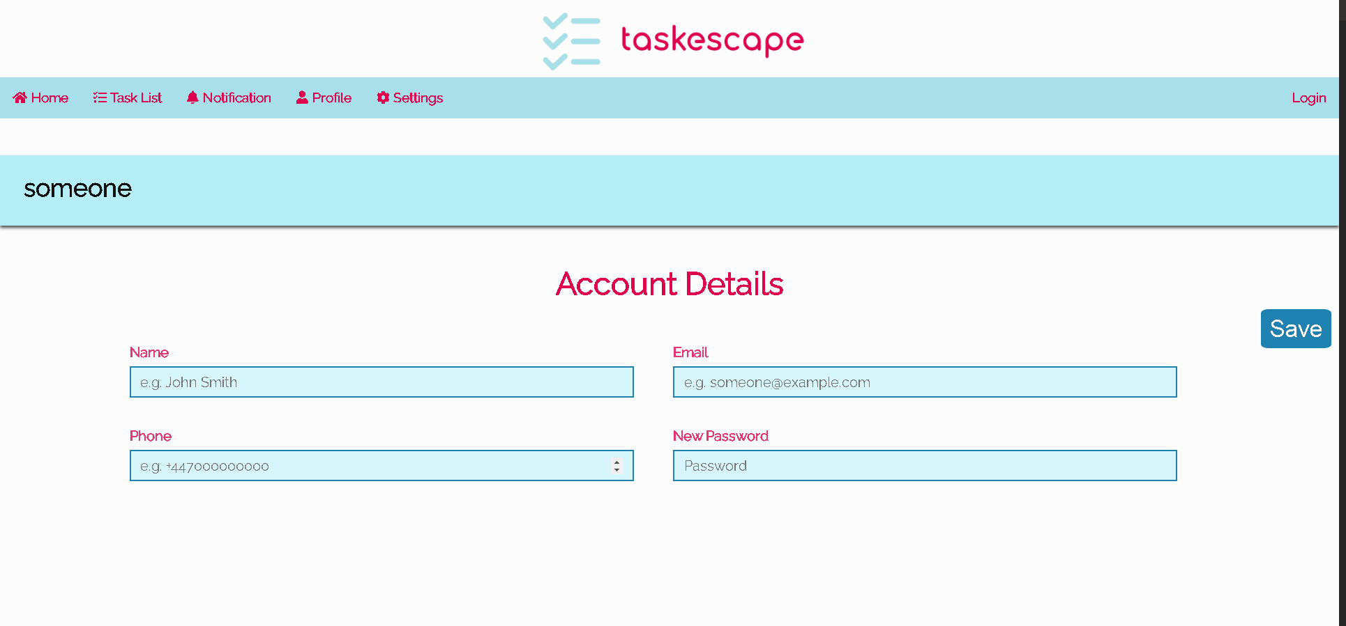

**Description**

When the profile tab is clicked this the page that will be displayed to the user. The profile header will contain the users’ username. In this page the user will be able to add account details like their name, phone number and email. Furthermore, they can update their password. The details are all saved using the button save.

**Functionality/features:**

* The username is loaded by the local storage from which was saved from the login form.
* Input fields to enter the account details.
* A button to save all the account details.
* If there are account details already entered for the user then the fields will be prefilled.
* The details are saved by updating the local storage with the account detail upon clicking the save button.
  + Without being connected a database this is page just shows how it would look if a user were able to login in.

**Requirements met:**

* View profile details.
* Edit account details.

**Accessibility:**

* A similar theme has been used for the inputs as the create and edit task forms.
* Example placeholder text to tell the user what goes in the input fields.
* Clear labels to help the user.

# **Heuristic Evaluations and Usability Tests**

## **My Heuristic Evaluation**

1. Visibility of system status

When navigating through the site, each page has clear headings as to what the page is for. Each section within a page has clear headings to show where the user is currently is within the page. Furthermore, the buttons and text are colour changes when the hovering and the colour changes when they are selected, like the view buttons.

To make it more obvious to the user which page they are, it would be better if the navigation button changed colour after a click.

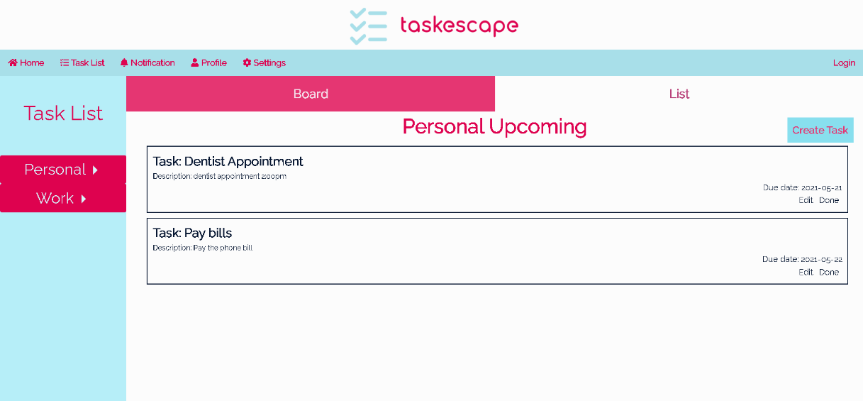

**Severity Rating: 1**

The user can tell where they are within the system using the headings and page content, however it would be easier if the buttons changed colour after selecting.

**2. Match between system and the real world**

The icons and words used through the system are commonly used in other systems, which helps the user to distinguish what the page or input field is for. The icons help to give a sense of familiarity with the system as well.

Drop boxes have been used to navigate between upcoming and done section. Since drop boxes is a common UI design trope, a user would be able to use these with ease. Furthermore, drop lists helps the user to view and select which option they want when there are multiple options to pick from.

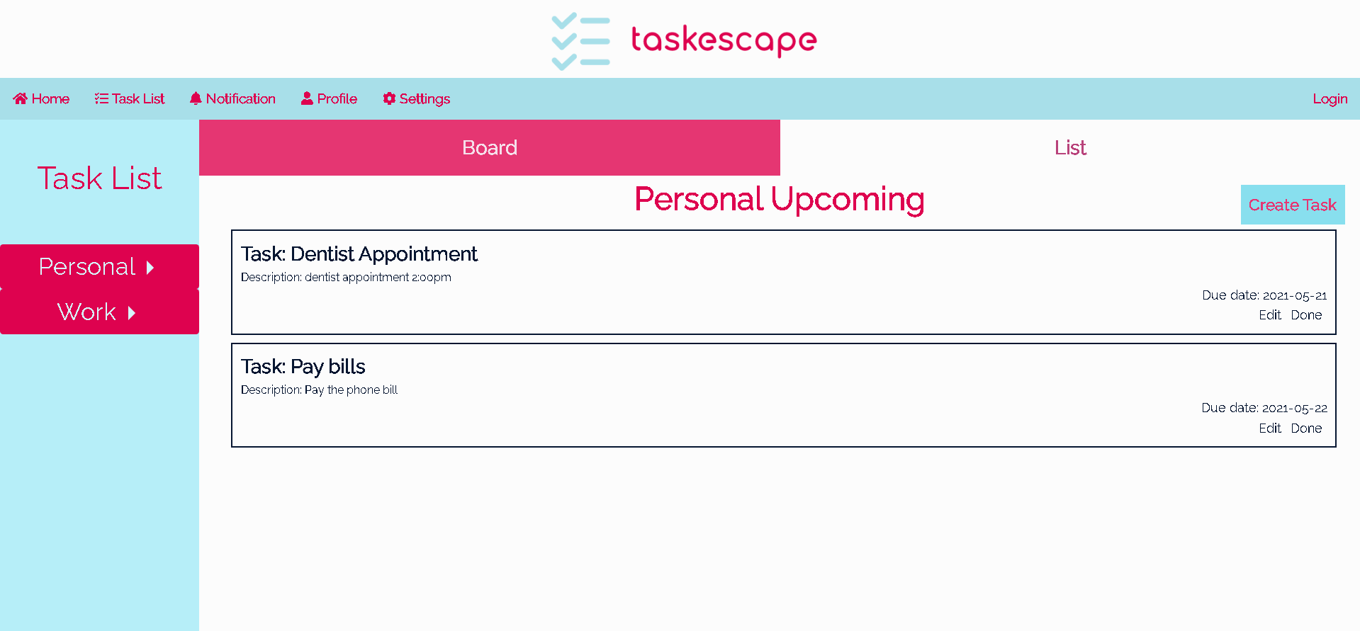

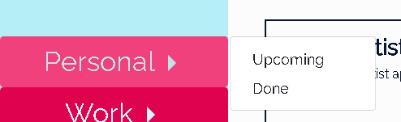

**Severity Rating: 0**

The system uses common icons and UI tropes, so the user would feel comfortable when interacting with the system.

**Heuristic 3: Consistency & standards**

Each page uses a similar theme which prevents the user from being overload with colours when navigating through the pages. The fonts of the text are all consistent with a differentiation of the different texts using size, colour, and weight. Within the task list page, a consistent layout is used for each category and the sections, hence easier navigation through the tasks and be able to retrieve the information with less complications. The same layout for the create and edit task form has been used, as such it is less likely for the user to have a confusion and no need for them to learn something new as it is the same exact process. The typography of the headings and subheadings are all consistent, with a differentiation between the two using sizing.



**Severity Rating: 0**

All pages and icons are consistent, each having similar layouts. There are no drastic changes when navigating through the system.

**Heuristic 4: User control & freedom**

If a task detail or due date has changed, the user is able to edit the task to update it with the correct details. They can close the pop-ups using the close icon in the top right corner. If they no longer need a task the user can delete the task.

However, in the profile or settings page there is no option to delete their account, thus unable to remove their personal information if they wish to furthermore, they are unable to undo an action if they wish to.



**Severity Rating: 3**

This is a major usability problem as the user will want to have an option to delete their account if they no longer want it, as such it should be very important to implement a way for the user to accomplish this.

**Heuristic 5: Error prevention**

Input fields like in the create task form have placeholder text that give examples as to what kind of details should be entered into the field. A date picker has been used for the user to select a due date in the create and edit task forms, prevents the user from selecting the incorrect date.

More error prevention is needed, to prevent users from mis-clicks triggering an operation like mark as done, no way to cancel. Furthermore, when creating a task if submit task is clicked without having all the details entered, then an incomplete task will be created hence a way to prevent this is needed.

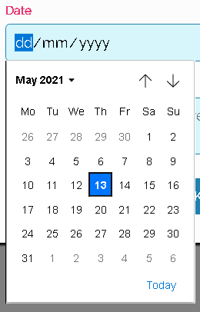

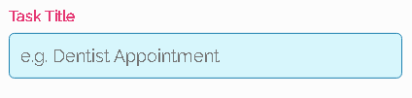

**Severity Rating: 4**

Needs a way to cancel mis-clicks and prevent submitting incomplete tasks.

**Heuristic 6: Recognition rather than recall**

The icons used in the navigation bar allows the user to select the page they wish to navigate to by recognising the common icon, which would tell them what the page is for.

The system does not have a way to filter the tasks to make it easier for the user to find tasks that match a certain criterion, hence if a user has many tasks this can be problem. There is no way for a user who would benefit from pictures as the task description to do so which would help with recognition.

**Severity Rating: 2**

A way to filter and search for tasks and to incorporate more images and make the site more accessible to benefit from visuals, less text to remember.

**Heuristic 7: Flexibility & Efficiency of use**

The system does not provide the user any shortcuts, a way to automate a task or function, the user must do everything manually.

**Severity Rating: 2**

Although there are no options for the user to automate or use short cuts to do a task, the user is still able to do the things they want as such this is a minor usability problem.

**Heuristic 8: Aesthetic & minimalist design**

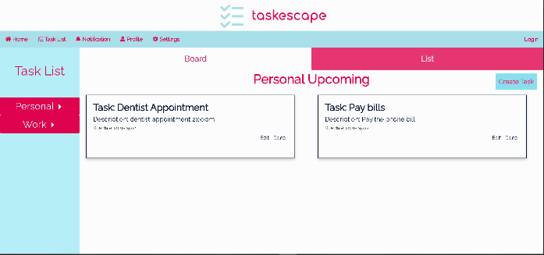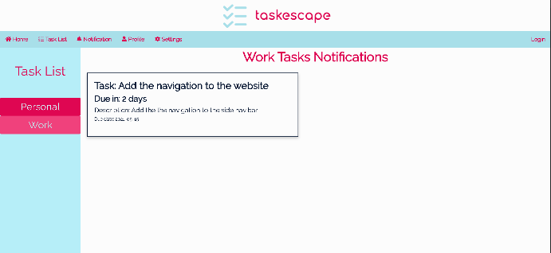The system is simple, organised, and clear, where the user can view all the information without being overwhelmed. Different perspectives allow the user to change the view to what they prefer. Every button and drop-down is clear to the user as what their function is for.

**Severity Rating: 0**

The visuals of the system are simple for the user to follow with no major flaws, with all buttons and sections being clearly labelled and shown.

**Heuristic 9: Ability to identify and recover from errors.**

The system does not show any error messages if something does go wrong, like leaving an input field blank, it does not show an error messages that could help the user to fix this error.

**Severity Rating: 3**

The user needs more feedback from the system if something does go wrong, so they are able to pinpoint what caused the error and fix it themselves, reducing time wasted on finding the cause.

**Heuristic 10: Help & Documentation**

All text fields have placeholder text to indicate to the user what they need to do, the buttons are self-explanatory as well. The system has a guide on how to use the task list page on the homepage, which provides a bullet point list guide on how to use the features of the task manger.

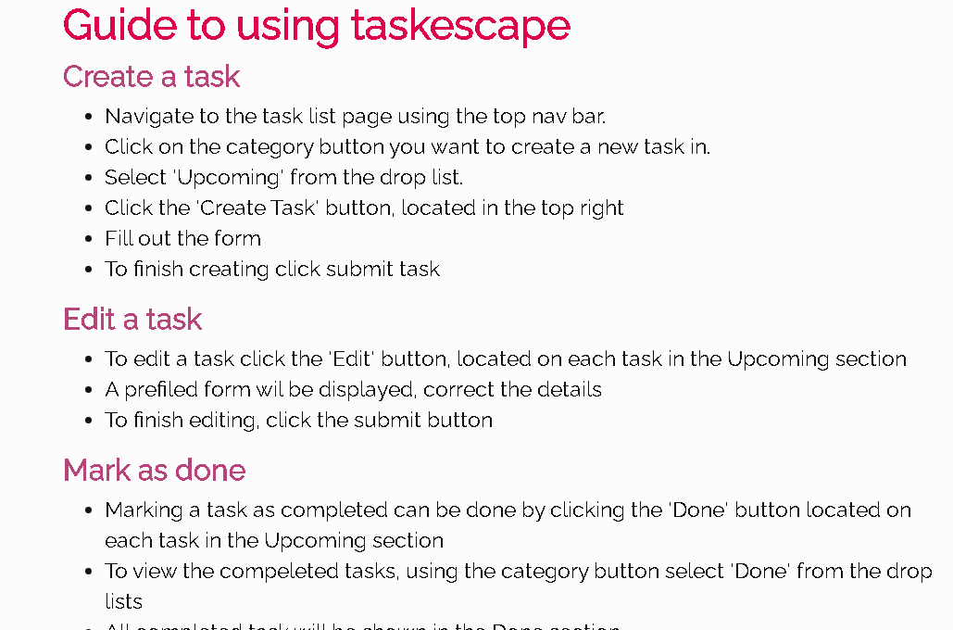

**Severity Rating: 0**

If the user needs help with the system, they can refer to this guide.

## Usability Test

1. Start from the homepage, read the guide on how to use the task list page features, once you have read the guide move on to the next task.
   * This test checks if they find the guide on how to use the features of the task list page helpful or not.
2. Navigate to the task list page, from there select the category task you want to add a task to, from the drop list navigate to Upcoming tasks.
   * Tests checks if they can navigate between the 2 categories easily or not.
3. Create a new task using the Create Task button, enter all the task details into the form. Once all details have been entered submit the task.
   * This task tests to see if the user can fill out the form and create the task without any problems or not.
4. Change the view of the tasks.
   * Tests if they can tell which button changes the view of the tasks.
5. Navigate to the other category and repeat task 3 to add a task to this category.
   * This test checks if they can repeat what they have just done a few seconds ago again, checks if creating the task is difficult to repeat or not.
6. Now edit the task you have just created changing the due date to 3 days from today’s date. Once changed, submit these changes and check if the task has been updated.
   * Tests if the user can edit the task without any difficulties, using the same form when creating the tasks.
7. Now navigate to the notification page. Select the category where you had just created a new task. You should be able to see the task you had just created with days due in 3 days.
   * Tests if they can view the notifications for a task, they have just edited.
8. Now mark the task you have just created as done.
   * This task checks whether they can recall the guide on the marking a task as done and if they are now able to navigate through the system or not.
9. Navigate to the done section to view the completed task.
   * Checks if they have marked the task as done correctly.
10. Delete the task.
    * Tests to see if they can recall the guide or tell how the test can be deleted.
11. Navigate to the settings page, change the theme to dark and change the font family to Arial.
    * Tests to see if they can navigate to the correct page and can tell which settings does the following from the test.
12. Click the Login button, enter a username and password, once entered sign in.
    * Tests the login form if the form is clear and readable.
13. Navigate to the profile page, you should see your username. Fill in the account details section, once all details have been entered press save.
    * Tests if the user can fill in the account details correctly.
14. Navigate to another random page and then navigate back to the profile page, you should see your details prefilled, change one of them and navigate back and forth again to check if the detail has changed or not.
    * Checks if the account details have been successfully changed or not.

**[END OF USABILITY TEST]**

## User: Accountant

### HE Form

**1. Visibility of system status**

**Evaluation**

It is easy to tell where I am on the website cause of the titles however it would better if the colour changed for menu after I clicked like other websites do.

**Severity Ranking**

1

**2. Match between system and the real world**

**Evaluation**

Icons recognisable since they are used in other sites and terminology used like the text ‘SUBMIT’ k is a commonly used when you are submitting a form online.

**Severity Ranking**

0

**3. Consistency and Standards**

**Evaluation**

The website has a consistent layout with a consistent theme with all buttons doing what they are supposed to do with all of them being appropriately named.

**Severity Ranking**

**0**

**4. User control and freedom**

**Evaluation**

It is easy to close the popup windows if I clicked the button by mistake using the close button. When moving a task to done I accidently moved another task to done, there was no way for me to move undo this.

**Severity Ranking**

**4**

**5. Error Prevention**

**Evaluation**

The text boxes all have example text. The date picker makes it easy to select the correct date.

**Severity Ranking**

**0**

**6. Recognition rather than recall**

**Evaluation**

The site icons and text make it easy to recognise what the page or feature is for but what is difficult is that you need to remember the tasks you have created. No way to easily filter out tasks to find the task you want.

**Severity Ranking**

**3**

**7. Flexibility and efficiency of use**

**Evaluation**

There were no features that made things easier for me like to create a task I would still need to create it by using the button and form. Also deleting a task is only possible by first moving the task to done and then deleting it, there should be a shorter way to delete the task.

**Severity Ranking**

**2**

**8. Aesthetic and minimalist design**

**Evaluation**

Each page within the website contains only the relevant information. The simple theme and layout make it easy to see all the data without being overloaded.

**Severity Ranking**

**0**

**9. Ability to identify and recover from errors.**

**Evaluation**

I did not see anything that indicates any error messages that could help to fix a problem, this should be implemented as having no error messages does make it difficult to use the site since I have no idea what needs to be fixed.

**Severity Ranking**

**3**

**10. Help and documentation**

**Evaluation**

The guide on the homepage is helpful as it explains how to use the task manager with simple bullet point instructions. It is easy to find since it is on the homepage, but I think it would be better if there was a separate page for the guide as I do find it strange it being on the homepage.

**Severity Ranking**

1

### Usability Test

|  |  |  |  |  |
| --- | --- | --- | --- | --- |
| Tests | Number of clicks | Task time | Errors | Successful task completion |
| Test 1 | N/A | 1:09.04 | 0 | YES |
| Test 2 | 6 | 0:34.11 | 0 | YES |
| Test 3 | 7 | 0:41.05 | 0 | YES |
| Test 4 | 1 | 0:06.44 | 0 | YES |
| Test 5 | 9 | 0:40.48 | 0 | YES |
| Test 6 | 4 | 0:19.38 | 0 | YES |
| Test 7 | 2 | 0:15.54 | 0 | YES |
| Test 8 | 5 | 0:31.11 | 0 | YES |
| Test 9 | 4 | 0:12.38 | 1 | YES |
| Test 10 | 1 | 0:08.34 | 0 | YES |
| Test 11 | 4 | 0:21.21 | 0 | YES |
| Test 12 | 4 | 0:24.02 | 0 | YES |
| Test 13 | 7 | 0:43.72 | 0 | YES |
| Test 14 | 5 | 0:30.76 | 0 | YES |

## User: University Student

### HE Form

**1. Visibility of system status**

**Evaluation**

The system keeps the user informed with the use of text, clearly telling the user which page/section you have navigated to. What could be improved is changing the appearance of buttons that are currently selected like the nav menu or which option is currently selected from the drop list.

**Severity Ranking**

1

**2. Match between system and the real world**

**Evaluation**

Words used in the system are commonly used in other system like delete or edit since these words are self-explanatory what they do. The use of a top navigation menu is something most users would be familiar with since most sites use this style of nav menu.

**Severity Ranking**

0

**3. Consistency and Standards**

**Evaluation**

System has a clear theme throughout the system no changes in the colours used on any page, this is the same even when in dark mode. All the buttons do what they are supposed to do with no variations between them.

**Severity Ranking**

**0**

**4. User control and freedom**

**Evaluation**

If the user, no longer wants to create or edit a task then they can close the popup form using the close button. The problem with the system is there is no way for the user to stop a function from taking place once activated, meaning if a task is moved to done there is no way to confirm if the user really wants to move it or has it been done by accident.

**Severity Ranking**

**4**

**5. Error Prevention**

**Evaluation**

All input fields within the system have placeholder text which provides an example of the type of data that should be entered. However, more error prevention is needed as the user can submit a task without filling in all the details.

**Severity Ranking**

**3**

**6. Recognition rather than recall**

**Evaluation**

The system needs a way to filter and search through tasks, as once the number of tasks reach a certain number it will become difficult to navigate through them without any filtering.

**Severity Ranking**

**3**

**7. Flexibility and efficiency of use**

**Evaluation**

The system has a lack of shortcuts to make it easier for a user. The system should provide a way to be able to copy tasks, so they do not need to recreate tasks.

**Severity Ranking**

**2**

**8. Aesthetic and minimalist design**

**Evaluation**

The design of the system is simple with no overloading of information, only relevant information on each page is shown to the user.

**Severity Ranking**

**0**

**9. Ability to identify and recover from errors.**

**Evaluation**

System has a lack of error messages; it needs error messages which would provide some feedback to the user as to what went wrong in case an error does occur.

**Severity Ranking**

**2**

**10. Help and documentation**

**Evaluation**

Help guide on how to use the task manager features located on the homepage makes it easy to find and access if the user needs to look up how to do something. The guide could do with some more information on how to use the rest of the site. Furthermore, to make the site more accessible to others, the help could use images alongside the text to make it clear to the user what they need to do.

**Severity Ranking**

1

### Usability Test 2

|  |  |  |  |  |
| --- | --- | --- | --- | --- |
| Tests | Number of clicks | Task time | Errors | Successful task completion |
| Test 1 | N/A | 0:52.14 | 0 | YES |
| Test 2 | 4 | 0:09.46 | 0 | YES |
| Test 3 | 8 | 0:20.47 | 0 | YES |
| Test 4 | 1 | 0:04.12 | 0 | YES |
| Test 5 | 9 | 0:36.77 | 1 | YES |
| Test 6 | 4 | 0:9.39 | 0 | YES |
| Test 7 | 3 | 0:16.09 | 1 | YES |
| Test 8 | 8 | 0:33.49 | 2 | YES |
| Test 9 | 2 | 0:07.55 | 0 | YES |
| Test 10 | 1 | 0:06.56 | 0 | YES |
| Test 11 | 6 | 0:10.58 | 0 | YES |
| Test 12 | 4 | 0:16.66 | 0 | YES |
| Test 13 | 9 | 0:37.54 | 1 | YES |
| Test 14 | 6 | 0:26.74 | 0 | YES |

## User: Food Manufacturer Worker

### HE Form

**1. Visibility of system status**

**Evaluation**

I was able to tell where I was on the website. The headings helped me to tell me which page I clicked on.

**Severity Ranking**

0

**2. Match between system and the real world**

**Evaluation**

The icons used next to the menu text are easy to recognise, I was able to tell what the page is for.

**Severity Ranking**

0

**3. Consistency and Standards**

**Evaluation**

The pages on the website all used the same colour scheme.

**Severity Ranking**

**0**

**4. User control and freedom**

**Evaluation**

I was able to edit tasks if I needed to change the details. What could be improved is when I made a mistake, like clicking done on the wrong task I was not able to undo this mistake, I think there needs to be a way to undo these mistakes.

**Severity Ranking**

**3**

**5. Error Prevention**

**Evaluation**

The input fields have examples which made it easier to know what I should write in them which made sure I would not make a mistake.

**Severity Ranking**

**0**

**6. Recognition rather than recall**

**Evaluation**

When creating the tasks, I would need to remember where I created it and when it is created, if there was a way to search for a recently made task it would make it easier for me.

**Severity Ranking**

**2**

**7. Flexibility and efficiency of use**

**Evaluation**

There were no shortcuts to make actions easier, if there was an action like copying a task so I would not need to recreate a whole new task every time.

**Severity Ranking**

**3**

**8. Aesthetic and minimalist design**

**Evaluation**

The website was very clean with no information crowded together.

**Severity Ranking**

**0**

**9. Ability to identify and recover from errors.**

* Expressed in plain language (no codes)
* Precisely indicate the problem
* Constructively suggest a solution.

**Evaluation**

I did not get any error messages; I think there should be error messages in case an error does happen.

**Severity Ranking**

**2**

**10. Help and documentation**

**Evaluation**

The help guide on how to use the features was very helpful and easy to find but I think what would make it better if the guide had pictures to show what the text is talking about.

**Severity Ranking**

1

### Usability Test 3

|  |  |  |  |  |
| --- | --- | --- | --- | --- |
| Tests | Number of clicks | Task time | Errors | Successful task completion |
| Test 1 | N/A | 2:34.76 | 0 | YES |
| Test 2 | 7 | 0:15.46 | 1 | YES |
| Test 3 | 12 | 0:54.76 | 1 | YES |
| Test 4 | 14 | 0:04.12 | 0 | YES |
| Test 5 | 11 | 1:07.86 | 1 | YES |
| Test 6 | 5 | 0:15.64 | 0 | YES |
| Test 7 | 5 | 0:26.09 | 0 | YES |
| Test 8 | 10 | 0:46.59 | 2 | YES |
| Test 9 | 2 | 0:12.87 | 0 | YES |
| Test 10 | 3 | 0:10.54 | 1 | YES |
| Test 11 | 7 | 0:17.27 | 1 | YES |
| Test 12 | 6 | 0:20.33 | 0 | YES |
| Test 13 | 11 | 0:57.91 | 2 | YES |
| Test 14 | 8 | 0:23.72 | 0 | YES |

## User: University Student 2

### HE Form

**1. Visibility of system status**

**Evaluation**

The user is informed of the system status via headings of the page and sections however more feedback is needed like changing the colour of currently selected page.

**Severity Ranking**

1

**2. Match between system and the real world**

**Evaluation**

Common words have been used for features that are used in other system like delete and edit. The system also has matching icons to other systems, giving a sense of familiarity for the user.

**Severity Ranking**

0

**3. Consistency and Standards**

**Evaluation**

The same form layout has been used for the create and edit task forms therefore the user does not need to learn anything, both forms work in the same exact way.

**Severity Ranking**

**0**

**4. User control and freedom**

**Evaluation**

The user can delete the task by moving the task to the done section. They can close popup forms using the close icon. However, the system needs a way to prevent mis-clicks, as there is no way to cancel an action or undo the action.

**Severity Ranking**

**4**

**5. Error Prevention**

**Evaluation**

The systems’ input fields all have example placeholder text explaining to the user what they should enter the input fields. However more error prevention is needed as when creating a task all the field not required hence you can create a task missing data.

**Severity Ranking**

**3**

**6. Recognition rather than recall**

**Evaluation**

Icons makes it easy to recognise what the navigation menu button is for. However, the lack of search tools makes it difficult to find the specific task you want you would need to remember what the task was instead of simply recognising it through filtering.

**Severity Ranking**

**3**

**7. Flexibility and efficiency of use**

**Evaluation**

The system has no features that provide a way for the user to complete an action quicker.

**Severity Ranking**

**2**

**8. Aesthetic and minimalist design**

**Evaluation**

The system has a simple design with each page only containing the relevant content.

**Severity Ranking**

**0**

**9. Ability to identify and recover from errors.**

**Evaluation**

The system has no error messages which is why it is important to implement these, so if a user leaves an input field empty an error message is shown to the user. This would allow them to know what went wrong.

**Severity Ranking**

**3**

**10. Help and documentation**

**Evaluation**

The bullet point list guide is detailed enough to help a new user how to use the features of the task manager, however the guide needs to include other areas of the system in case the user needs help. Furthermore, pictures should be used with the guide to make it more helpful and accessible to all users.

**Severity Ranking**

1

### Usability Test 4

|  |  |  |  |  |
| --- | --- | --- | --- | --- |
| Tests | Number of clicks | Task time | Errors | Successful task completion |
| Test 1 | N/A | 1:26.38 | 0 | YES |
| Test 2 | 3 | 0:12.33 | 0 | YES |
| Test 3 | 6 | 0:35.01 | 0 | YES |
| Test 4 | 1 | 0:03.49 | 0 | YES |
| Test 5 | 9 | 0:39.94 | 1 | YES |
| Test 6 | 4 | 0:18.39 | 0 | YES |
| Test 7 | 3 | 0:14.09 | 0 | YES |
| Test 8 | 6 | 0:21.86 | 0 | YES |
| Test 9 | 2 | 0:07.46 | 0 | YES |
| Test 10 | 1 | 0:07.42 | 0 | YES |
| Test 11 | 5 | 0:14.48 | 0 | YES |
| Test 12 | 4 | 0:12.33 | 0 | YES |
| Test 13 | 8 | 0:32.95 | 0 | YES |
| Test 14 | 7 | 0:28.07 | 0 | YES |

## User: Digital Marketer

### HE Form

**1. Visibility of system status**

**Evaluation**

The system does provide feedback of where the user currently is with clear headings however, the navigation menu buttons do not change colour once selected which would be helpful when navigating back and forth.

**Severity Ranking**

1

**2. Match between system and the real world**

**Evaluation**

Simple, familiar, and self-explanatory words have been used for buttons like edit and create task.

**Severity Ranking**

0

**3. Consistency and Standards**

**Evaluation**

The same form layout has been used for the create and edit task forms therefore the user does not need to learn anything, both forms work in the same exact way.

Layout for each category is the same, which avoids confusion when navigating through the different categories as there are no drastic changes. Buttons that appear more than once within the system have no differences of the functionality changing through the system.

**Severity Ranking**

**0**

**4. User control and freedom**

**Evaluation**

It is a shame that you are unable to undo an action like deleting or editing a task would make it more convenient for the user, but more over there is no way to cancel an operation once started this should be implemented to prevent mistakes.

**Severity Ranking**

**4**

**5. Error Prevention**

**Evaluation**

Placeholder text within the input fields give and idea of what should be inputted into the fields which prevents users from making a mistake. However, there is no way to prevent accidental clicks from happening, there needs to be a way to prevent these.

**Severity Ranking**

**4**

**6. Recognition rather than recall**

**Evaluation**

The notification section shows all the task details alongside the days left, which helps the user from trying to remember what the task details are. It is easy to retrieve the guide for the system since it is located on the homepage. What could be added is filtering to make searching for task easier.

**Severity Ranking**

**2**

**7. Flexibility and efficiency of use**

**Evaluation**

The system does not provide a way to accelerate actions, if the system included these it would help to save time.

**Severity Ranking**

**2**

**8. Aesthetic and minimalist design**

**Evaluation**

The system has a simple design with each page only containing the relevant content. The design is simple with a 2-colour scheme, blue and red of different shades, which helps to view all the information without being overloaded.

**Severity Ranking**

**0**

**9. Ability to identify and recover from errors.**

**Evaluation**

Did not see any error messages that would help to convey what went wrong, the system needs these to help a user know if they did something wrong or if it is a problem with the system itself.

**Severity Ranking**

**3**

**10. Help and documentation**

**Evaluation**

The guide for how to use the task manager on the homepage helps new users since it is the first page that new users would visit. The bullet point list for each functionality of the task manager provides brief steps on how to use function. However, the homepage could be done to look more aesthetically pleasing to users’ eyes since it is the first page new users would visit, images could be used to make it more welcoming then just having text.

**Severity Ranking**

1

### Usability Test 5

|  |  |  |  |  |
| --- | --- | --- | --- | --- |
| Tests | Number of clicks | Task time | Errors | Successful task completion |
| Test 1 | N/A | 0:43.75 | 0 | YES |
| Test 2 | 4 | 0:12.46 | 0 | YES |
| Test 3 | 9 | 0:25.75 | 0 | YES |
| Test 4 | 1 | 0:06.63 | 0 | YES |
| Test 5 | 8 | 0:37.45 | 1 | YES |
| Test 6 | 4 | 0:11.65 | 0 | YES |
| Test 7 | 3 | 0:17.81 | 0 | YES |
| Test 8 | 9 | 0:37.86 | 1 | YES |
| Test 9 | 2 | 0:08.65 | 0 | YES |
| Test 10 | 1 | 0:08.56 | 0 | YES |
| Test 11 | 7 | 0:10.58 | 0 | YES |
| Test 12 | 4 | 0:16.66 | 0 | YES |
| Test 13 | 9 | 0:40.52 | 0 | YES |
| Test 14 | 7 | 0:27.11 | 0 | YES |

# **Evaluation**

From the feedback received from the usability tests and heuristic form the system has some major heuristic violations which are all found and agreed upon by the 5 users. The findings found by the users will help to improve the system.

**Finding 1:** No way to undo or cancel operations.

All users found this to be a problem, that there was no way to undo operations as once an action is started the user is unable to revert to the original state or stop this action. This is shown, by all the users giving feedback how they are unable to undo a deletion. From the test observation most users made an error on test 5 or 8, which was moving the incorrect task to done, but there was no way form them to correct this error.

In the final product each operation that would change the system state would have a confirmation dialogue with a Yes or No option in case they clicked it by mistake. Furthermore, for the user to undo an action the final product should include undo toasts so the user can revert to the original state if they wish to.

**Finding 2:**  Filtering and Searching for tasks

From the feedback received users would like a way to filter and search through the tasks to make it easier for them to locate the task. As from the data collected some tasks had a high number of clicks or time to complete because they could not find the task as easily.

To improve the system to help users from wasting time, the final product should include a drop-list filters to filter tasks by a certain criterion. Also, if a user wants to find a specific task a search field should be provided for the user to quickly find it.

**Finding 3:** More error prevention and messages

The users stated that the system needs more error prevention as some accidently deleted the wrong task and there was no way to prevent this error in mis-click from occurring. Also, error messages need to be shown to the user as if an entry field is left blank the task would be created without the full details filled out, which was one of the errors that happened during test 5.

Before the final product can be launched this needs to be implemented, errors can be prevented with the confirmation dialogue, however messages are needed for the user to understand what went wrong.

**Finding 4:** Shortcuts for actions

Most users would prefer a shorter way to conduct certain operations, as it can become a waste of time to do some operations like deleting each induvial task, a way to delete more then one task at a time. To make it easier for users, shortcuts should be provided for the user in the final product like copying a task if they need to create a task like an existing one.

**Finding 5:** Visuals

Most users thought the system could use more visuals, like images in the guide to make the system more accessible to other users who would benefit from having images instead of text. Hence in the product an improved guide with images should be provided but also ways to incorporate images into tasks to help other users with special needs.

# Conclusion

In this portfolio I have developed a task manager system which contains all the necessary features for a task manager to be usable. It was successful in the sense that most requirements were met, and it matches closely to my original idea with the layout and functionality however, during development some features were cut out due to technical issues like not being connected to a database. Furthermore, some of the features developed are incomplete or need other features to improve them further to make them more usable. Which is why, to make this system into the starting point for the final product, the incomplete features must first be completed by adding the improvements and fixing the problems found by the users. The system also needs to be connected to a database so the system would behave like it would in the final product.